

High Level Design

ALL RIGHTS RESERVED

This is an unpublished work. No part of this document may be copied, photocopied, reproduced, translated, or reduced to any electronic or machine-readable form without the prior permission of Telefónica UK Limited

**PROJECT DOCUMENTATION**

|  |  |  |  |
| --- | --- | --- | --- |
| **Current Version** | 0.6 | | |
| **Version** | **Date** | **Changed by** | **Changes** |
| Version numbers managed by SharePoint | 24/01/2019 | Balchander Bobby | Draft Version 0.6 |
| 24/01/2022 | Madhusudhana Rao | Added review comments |
| 26/01/2022 | Aida Anna Tom | Added required changes |
| 04/04/2022 | Iranna Telasang | Amended additional details |
| 12/04/2022 | Iranna Telasang | Changes made as per the peer review |
|  |  |  |
|  |  |  |

**Approval History**

|  |  |  |  |
| --- | --- | --- | --- |
| Name | Role | Date of approval | Version approved |
| Chris Powell | Head of Security |  |  |
| Will Giles | IT Infra Designer |  |  |
| Alec Connolly | IT Architect |  |  |
| Swapnil Jain | Operation Lead SOA |  |  |
| Matt Ashbrook | Service Delivery Lead |  |  |
| Imran Khawaja | Integration Delivery Manager |  |  |
| Russel Fairfield | Service Delivery Manager |  |  |

**Additional Reviewers**

|  |  |
| --- | --- |
| Name | Role |
| Rajesh Kota | Solution Architect |
| Madhusudhana Rao | Supporting Solution Designer |
| Balchander Bobby | Project Manager |

Contents

1 INTRODUCTION 4

1.1 Project Summary 4

1.2 Project Scope 4

1.2.1 In Scope 4

1.2.2 Out of Scope 4

1.2.3 Assumptions 4

1.2.4 4Sight Features 5

2 ARCHITECTURE 6

2.1 4Sight Product Architecture 6

2.2 VMO2 4SIGHT Production Architecture 7

2.3 VMO2 4SIGHT Reference Architecture 7

3 SOLUTION DESCRIPTION 9

3.1 Overall Solution 9

4 USER MANUALS 10

4.1.1 User Manual 10

4.1.2 ML API Documentation 10

5 DATA IMPACTS 11

5.1 Information Governance 11

6 REPORTS & BI 12

7 4SIGHT INFRASTRUCTURE 13

7.1 Hardware, Data Centre and Hosting Options 13

8 Connectivity & Capacity Assessment 14

8.1 Prod Internal Connectivity 14

8.2 Prod External Connectivity 14

8.3 Prod Capacity Assessment 15

8.4 Ref Internal Connectivity 15

8.5 Ref External Connectivity 15

8.6 Ref Capacity Assessment 16

9 INSTALLATION AND DEPLOYMENT 17

9.1 Pre-requisite for Product installation 17

9.2 Software & License Details 17

10 Operational Impacts 19

# INTRODUCTION

## Project Summary

4Sight is a generic analytics & prediction framework from THIS. It is built to work with any source of data (logs, databases, streaming data etc.) and give insights to users. It can aggregate logs from all your systems and applications, analyse these logs, and create visualizations for application. The framework generates widgets which can be embedded into any existing applications, there by seamlessly bringing in analytics & prediction capabilities to an application. The complete product is API driven making it integrate with other applications to not just visualize but also utilize the analytic/prediction data within applications.

## Project Scope

### In Scope

* Install & integrate 4Sight with ESB servers and enabling the features like Widgets, Dashboard, Search, Prediction, Alerting that are in scope.
* Reference & Production environment support is in scope.
* Widgets, Dashboards Prediction & Alerting created for sanity testing in reference environment will be exported into the Production.
* 4Sight license is limited to only 1-Production [SiteA & SiteB] and 1-Reference environment.

### Out of Scope

* Only Application Log Monitoring is supported and 4sight does not provide any Service Monitoring capability.
* Performance Test is not in scope.
* No additional Widgets, Dashboards Prediction & Alerting will be created in Production.
* 4Sight does not have any report generation functionality.

### Assumptions

* It is assumed that end user will have all the permissions and once the Product team completes the installation the access will be removed.
* Timely support form end users to share all the necessary logs for support team (L3, L4) in the event of debugging.
* Further tool enhancement is subjected to CR.

Back To Contents

### 4Sight Features

* Widget - Widgets contains everything to derive insights from your data. It includes Dimensions, Metrics, Scripts, Sort, Visualizations and more.
* Dashboard - Dashboard is a collection of widgets that can be used to represent your data in a meaningful way. On a dashboard, variety of widgets can be added and rearranged for customization.
* Search - Search is an interactive web interface to search in your data based on different criteria like time, phrase, expression and user events.
* Prediction - Prediction models can be configured to get forecasted value based on a set of input parameters.
* Alerting - Alerts can be configured to notify if the value in a dataset has changed beyond a particular threshold. Mail alerts can be triggered based on the selected frequency. Alerts can be generated (Minute, Day, Week, Month). A daily alert is based on daily changes in traffic/behaviour; weekly and monthly alerts are based on week to week and month to month changes.

# ARCHITECTURE

## 4Sight Product Architecture

The core components of 4Sight are:

4Sight Server: This component provides the web interface for users to create widgets, dashboards, predictions. Users and groups for the application will be managed via "User & Control Management"

4Sight ML Server: This component manages the training of prediction models and provides API interface to consume predictions

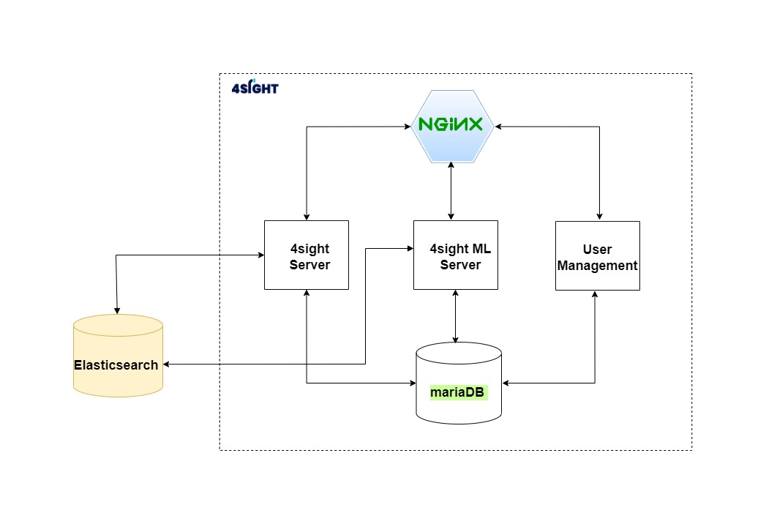

Figure 1 Architecture Diagram

## 

## VMO2 4SIGHT Production Architecture

Target Architecture consideration after integrating 4Sight with ESB 12c servers. 4Sight servers will also be a part of ITPC similar line to how the 12c ESB servers are placed. There will be auto application log transfer that will take place from all the 12c ESB server to 4Sight as shown in the below diagram, which will be then pushed to different component of 4Sight to consume for the data interpretation.

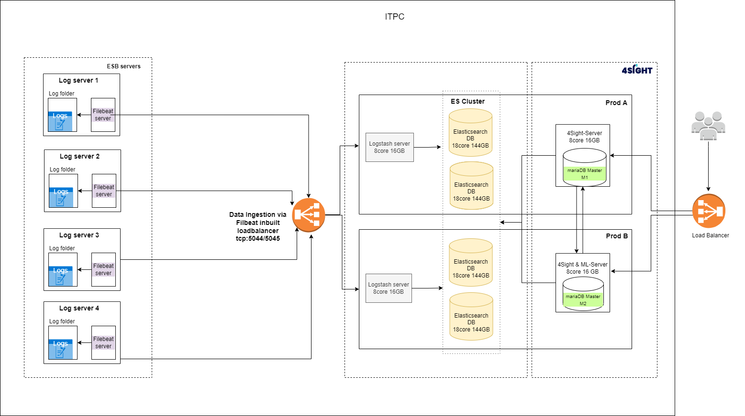

## VMO2 4SIGHT Reference Architecture

4SIGHT will also be installed on Ref Func environment with scaled down architecture of the Production setup.We are utilizing the exiting BPEL Site-A Architecture for the 4Sight reference setup. Below is the architecture diagram for the reference environment.

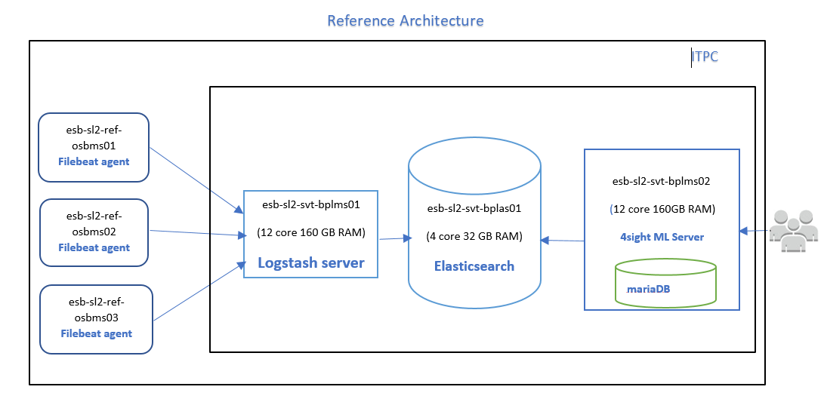



Back To Contents

# SOLUTION DESCRIPTION

Refer to the following solution listed below to cover the overall solution after 4sight implementation.

## Overall Solution

The following approach will be considered during the implementation of filebeat in ESB 12c servers.

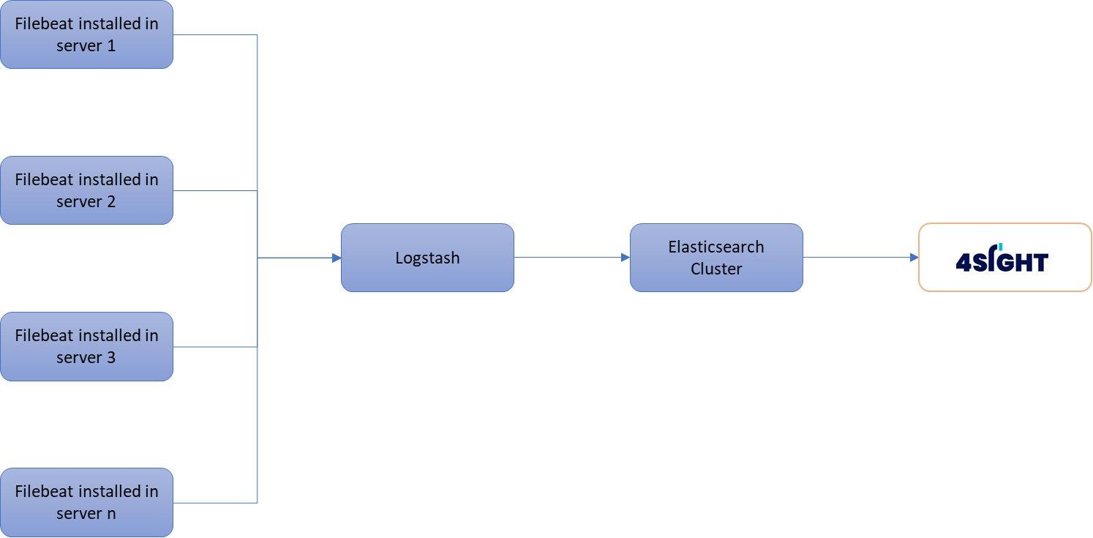

# USER MANUALS

### User Manual

Please refer the below link for the online documentation of the 4Sight product where the details of 4Sight product features is given for the end-user to create, delete, import, export, view.

<https://docs.dm4sight.com/1.2/4Sight.html#sight-web-interface>

### ML API Documentation

Please refer the below link to get the details of how an end user can consume the API to see the prediction on their datasets.

<https://docs.dm4sight.com/1.2/4Sight.html#sight-ml-api-s>

Back To Contents

# DATA IMPACTS

There is no change to data impacts as part of this design.

## Information Governance

This design is not impacting any data that Information Governance classify as sensitive therefore opting out of Information Governance.

# REPORTS & BI

NA

Back To Contents

# 4SIGHT INFRASTRUCTURE

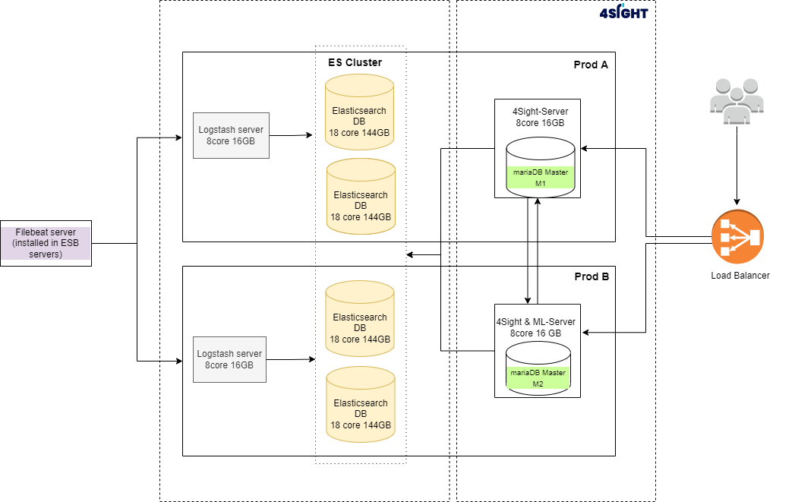

## Hardware, Data Centre and Hosting Options

|  |  |  |  |  |
| --- | --- | --- | --- | --- |
| **SI NO.** | **Component Name** | **Site** | **Configuration** | **Class of Service** |
| 1 | Production instance for 4sight-Server | A | vCPU 8 Core, 16 GB RAM, 250 GB Storage | Platinum |
| 2 | Production instance for 4sight-Server_ML | B | vCPU 8 Core, 16 GB RAM, 250 GB Storage | Platinum |
| 3 | Elasticsearch Server1 | A | vCPU 18 Core, 144 GB RAM, 5000 GB Storage | Platinum |
| 4 | Elasticsearch Server2 | B | vCPU 18 Core, 144 GB RAM, 5000 GB Storage | Platinum |
| 5 | Elasticsearch Server3 | A | vCPU 18 Core, 144 GB RAM, 5000 GB Storage | Platinum |
| 6 | Elasticsearch Server4 | B | vCPU 18 Core, 144 GB RAM, 5000 GB Storage | Platinum |
| 7 | Logstash Server1 | A | vCPU 8 Core, 16 GB RAM, 250 GB Storage | Platinum |
| 8 | Logstash Server2 | B | vCPU 8 Core, 16 GB RAM, , 250 GB Storage | Platinum |

# Connectivity & Capacity Assessment

## Prod Internal Connectivity

Connectivity required between 4sight Logstash servers and ESB 12c servers where log data needs to be monitored.

Connectivity within the 4sight product servers is mentioned in the following table.

|  |  |  |  |  |  |  |
| --- | --- | --- | --- | --- | --- | --- |
| **SI. NO** | **Component Name** | **Server** | **INBOUND/ OUTBOUND** | **Ports** | **FROM/TO** | **Comments** |
| 1 | Production instance for 4sight-Server | 4sight-Server | INBOUND | TCP: 80 | 4sight-server |  |
| INBOUND | TCP:80 / TCP:443 | Load Balancer | For communication with LB |
| OUTBOUND | TCP: 3306 | MariaDB | To communicate with Maria database. |
| OUTBOUND | TCP: 5000 | 4sight-server | To Communicate with ML Server |
| 2 | Production instance for 4sight-Server_ML | 4sight-Server_ML | INBOUND | TCP: 80 | 4sight-server |  |
| INBOUND | TCP:80 / TCP:443 | Load Balancer | For communication with LB |
| OUTBOUND | TCP: 3306 | MariaDB | To communicate with Maria database. |
| OUTBOUND | TCP:  5000 | 4sight-server | To Communicate with 4sight Server |
| 3 | Elasticsearch Server1 | Elasticsearch Server1 | INBOUND | TCP:9200 / TCP:9300 | ES ports |  |
| 4 | Elasticsearch Server2 | Elasticsearch Server2 | INBOUND | TCP:9200 / TCP:9300 | ES ports |  |
| 5 | Elasticsearch Server3 | Elasticsearch Server3 | INBLOUND | TCP:9200 / TCP:9300 | ES ports |  |
| 6 | Elasticsearch Server4 | Elasticsearch Server4 | INBOUND | TCP:9200 / TCP:9300 | ES ports |  |
| 7 | Logstash Server1 | Logstash Server1 | INBOUND/ OUTBOUND | TCP: 5044 |  |  |
| 8 | Logstash Server2 | Logstash Server2 | INBOUND/ OUTBOUND | TCP: 5044 |  |  |

## Prod External Connectivity

NA

## Prod Capacity Assessment

Capacity assessment has been carried out by referring the current [~10M] & future [~15M] daily API transactions and the size of the log file that is generated for the same. Elasticsearch generates a daily log file of size 165 GB and the copy will be kept to cover the disaster situation which will be maintained for 30 days, we have also included a buffer of additional 25% to cover the peak transaction if in case. This assures that current & future growth for monitoring the application log has been taken into consideration.

|  |  |
| --- | --- |
| Total Logs Size Per Day | 165 GB |
| Replication factor | 3 |
| Logs Retention Period in Elasticsearch | 30 days |
| Total Logs Size of Elasticsearch Cluster [165*30*3*1.25(buffer)] | 18563 GB |
| Latency requirement for Elasticsearch | **2 to 5 milli seconds** between cluster nodes |

## Ref Internal Connectivity

Connectivity required between Reference Logstash servers and ESB sl2 servers where log data needs to be monitored.

Connectivity within the 4sight product servers is mentioned in the following table.

|  |  |  |  |  |  |  |
| --- | --- | --- | --- | --- | --- | --- |
| **SI. NO** | **Component Name** | **Server** | **INBOUND/ OUTBOUND** | **Ports** | **FROM/TO** | **Comments** |
| 1 | Reference instance for 4Sight ML Server | 4Sight ML Server | INBOUND | TCP:80 / TCP:443 | For application users |  |
| 2 | Elasticsearch Server | Elasticsearch Server | INBOUND | TCP:9200 / TCP:9300 | ES ports |  |
| 3 | Logstash Server | Logstash Server | INBOUND/ OUTBOUND | TCP: 5044 |  |  |

## Ref External Connectivity

NA

## Ref Capacity Assessment

|  |  |
| --- | --- |
| Total Logs Size Per Day | 10 GB |
| Replication factor | 1 |
| Logs Retention Period in Elasticsearch | 7 days |
| Total Logs Size of Elasticsearch Cluster  [10*1*7*1.25(buffer)] | 88 GB |

# INSTALLATION AND DEPLOYMENT

## Pre-requisite for Product installation

* Require Domain name, Certificate, Certificate Key File, CA(Root) certificate (if SSL is required)
* Require Oracle Java or Adopt OpenJDK/openjdk11 on all the machines.
* Enable connectivity between Production instance for 4sight-Server_ML and Production instance for 4sight-Server for MariaDB Master-Master configuration.
* Enable connectivity between Production instance for Elasticsearch Server1, Production instance for Elasticsearch Server2, Production instance for Elasticsearch Server3 and Production instance for Elasticsearch Server4 for Elasticsearch Master-Data node configuration.
* Enable connectivity between Filebeat server (client/external server) and Logstash server1 and Logstash Server2.
* MariaDB server 10.4 installation on 4sight-Server_ML and 4sight-Server.
* MariaDB client 10.4 installation on 4sight-Server_ML and 4sight-Server.
* Elasticsearch 7.16.3 installation on Elasticsearch Server1, Elasticsearch Server2, Elasticsearch Server3 and Elasticsearch Server4.
* Logstash 7.16.3 installation on Logstash Server1 and Logstash Server2
* Below details are required for email configuration to send and receive notifications
  + Email server host and port
  + Sender email address & App Password

## Software & License Details

|  |  |  |  |  |
| --- | --- | --- | --- | --- |
| **S.**  **No** | **Software** | **Versions** | **License** | **Comments** |
| 1 | Nginx | 1.20.1 | BSD 2-Clause |  |
| 2 | ModSecurity | 3.0.4 | Apache License 2.0 |  |
| 3 | OpenSSL | 1.0.2k | OpenSSL License |  |
| original SSLeay license |
| 4 | Gunicorn | 20.0.4 | MIT license |  |
| 5 | Python | 3.6.12 | PSF License |  |
| 6 | Pip | 3.6.1 | MIT license |  |
| 7 | Elasticsearch | 7.16.3 | Elastic License | Elasticsearch needs to be installed by O2 |
| 8 | Logstash | 7.16.3 | Elastic License | Logstash needs to be installed by O2 |
| 9 | Keycloak | 15.0.2 | Apache License 2.0 |  |
| 10 | Java | Oracle Java or Adopt OpenJDK/openjdk11 | Oracle Licence for Oracle Java | If Oracle Java is required, then same needs to be installed by O2.  If Adopt OpenJDK/openjdk11 required, this will be installed by THBS |
| 11 | MariaDB server | 10.4 | GNU GPL | MariaDB server needs to be installed by O2 ? |
| 12 | MariaDB client | 10.4 | GNU GPL | MariaDB client needs to be installed by O2 ? |

# Operational Impacts

NA

Back To Contents